1. **MANPOWER REQUEST**

**A1.0** Immediate Superior will create manpower request.

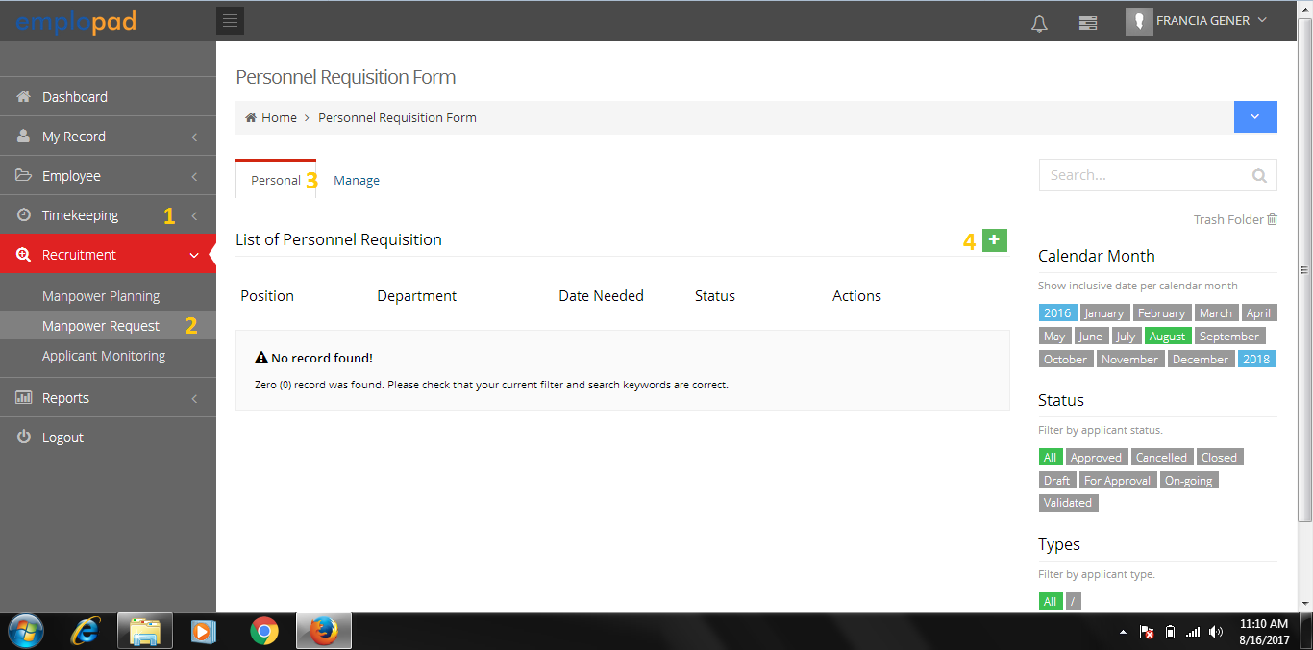

Personal Tab is for the requestor of manpower request

Manage Tab is for the approver of the manpower request.

List of all manpower requests under his/her department.

**A1.1** Personnel Requisition Form

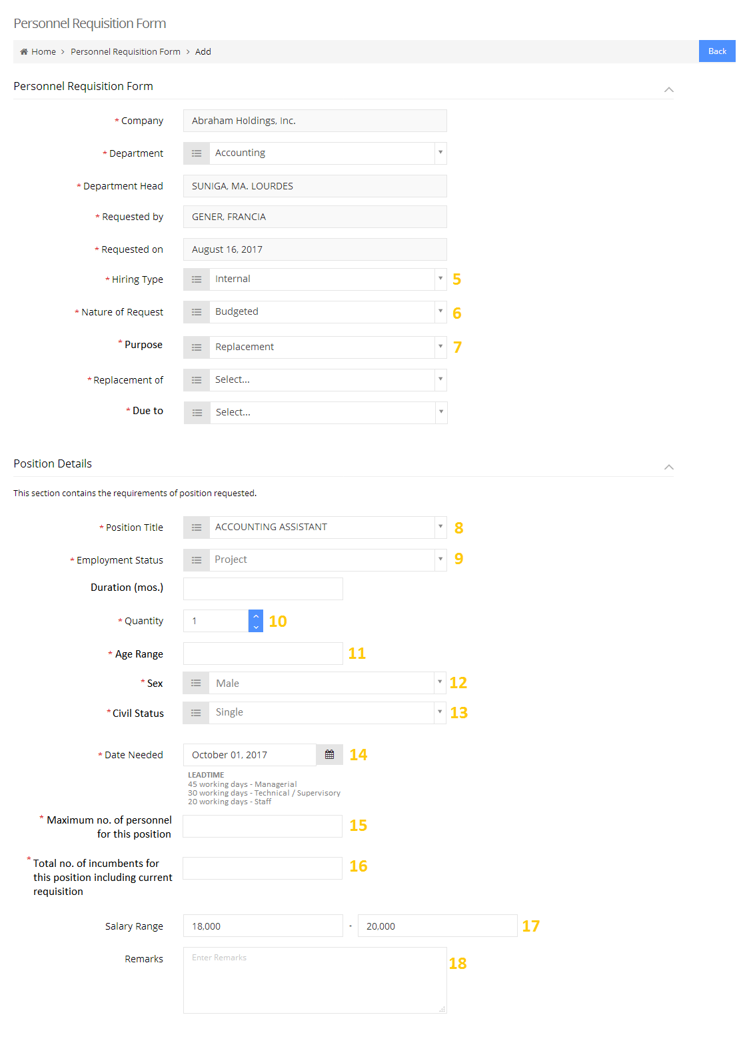

* Internal
* External
* Internal / External
* Budgeted
* Not Budgeted
* Change of Plan
* New Position
* Additional
* Replacement
* Select the name of employee for replacement
* Select the reason Due to:
* Resignation
* Retirement
* Termination
* Transfer to

(pop-up text field entry for location)

* Vacation/Sick/Maternity/Paternity Leave

(pop-up text field entry for date from and date to)

* Probationary
* Regular
* Project

(pop-up text field for duration)

* Casual

(pop-up text field for duration)

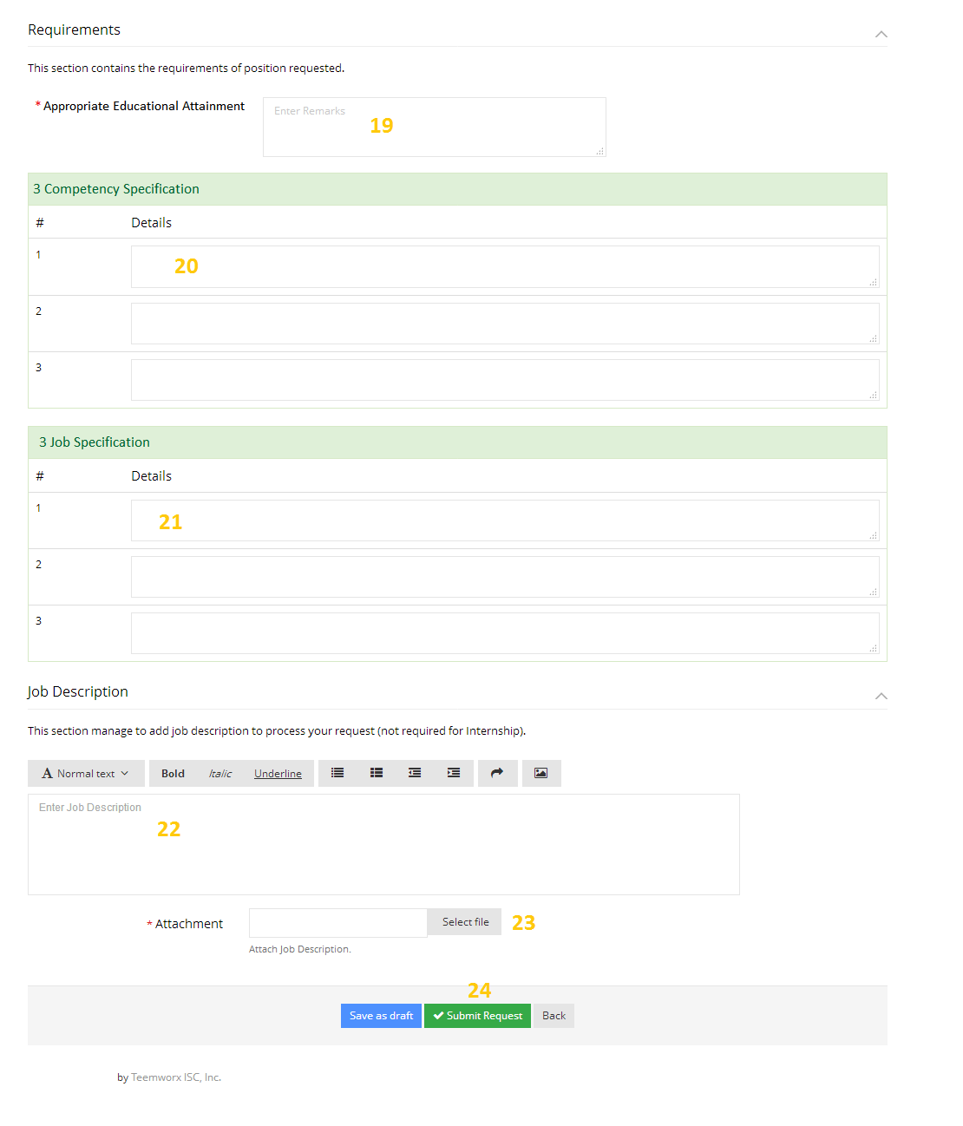

**A1.2** Submitted PRF will be sent to Department Head for approval.

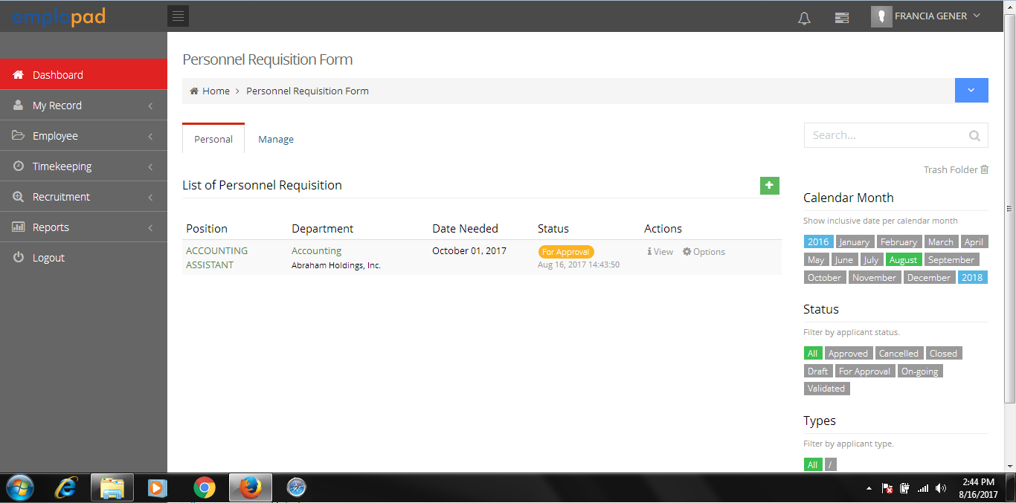

**A1.3** Personnel Requisition Form Printout

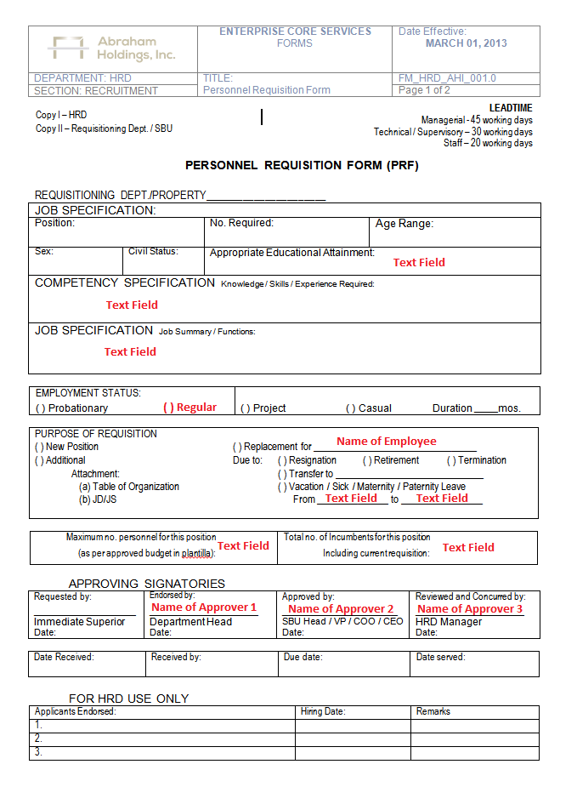

Display the list of selected candidates applying for the position

Additional entry field on PRF

Additional entry field on PRF

Additional pick list on PRF

Additional entry field on PRF